**CAPTURE MOMENTS-** **Photographer Booking Website**

**Project Description:**

**CaptureMoments** is a full-stack web application that allows users to discover and book professional photographers for various events such as weddings, birthdays, corporate gatherings, portraits, and more. The platform streamlines the booking process by offering detailed photographer profiles and a simple, intuitive form for scheduling services.

Built using **Flask** (Python) on the backend and **HTML/CSS with Bootstrap** on the frontend, the application integrates dynamic templates, responsive design, and real-time validations to ensure a smooth user experience. Users can select event types, choose preferred dates, specify event locations, and add notes during booking.

**Scenario 1: Smooth Photographer Booking Experience for Users**

The CaptureMoments platform is designed to deliver a seamless and responsive booking experience for users. Built on AWS EC2, the system ensures scalability and reliability even during peak usage periods. Users can log in, explore available photographers, and submit booking requests by filling out essential details such as event type, location, and date range. The Flask backend efficiently processes this data, stores it securely, and sends appropriate responses. Thanks to the cloud infrastructure, users experience minimal latency and uninterrupted service even during high-demand seasons like weddings or festivals..

**Scenario 2: Effortless Browsing and Selection of Photographers**

CaptureMoments allows users to browse and discover photographers based on categories such as wedding, portrait, birthday, and corporate photography. Each photographer has a dedicated profile that includes their name, specialty, and a profile image, enabling users to evaluate and choose professionals that match their needs. The system supports filtering and quick navigation, making the selection process straightforward. Flask manages all filtering and data fetching, while EC2 hosting ensures that the platform performs consistently across devices and locations. This design enhances the overall user experience and streamlines the journey from discovery to booking.

**Scenario 3: Validated Date Selection Prevents Booking Errors**

The booking system in CaptureMoments includes built-in validations to prevent scheduling conflicts and input errors. The date fields use a calendar-based picker that restricts users from selecting invalid combinations, such as an end date that precedes the start date or a booking duration longer than 14 days. If users attempt to submit incorrect inputs, the form provides immediate visual feedback and prevents submission until the issue is resolved. This validation mechanism, implemented using JavaScript and Flask, ensures data consistency and simplifies photographer workload management. It also contributes to a more professional and error-free user experience.

# AWS ARCHITECTURE

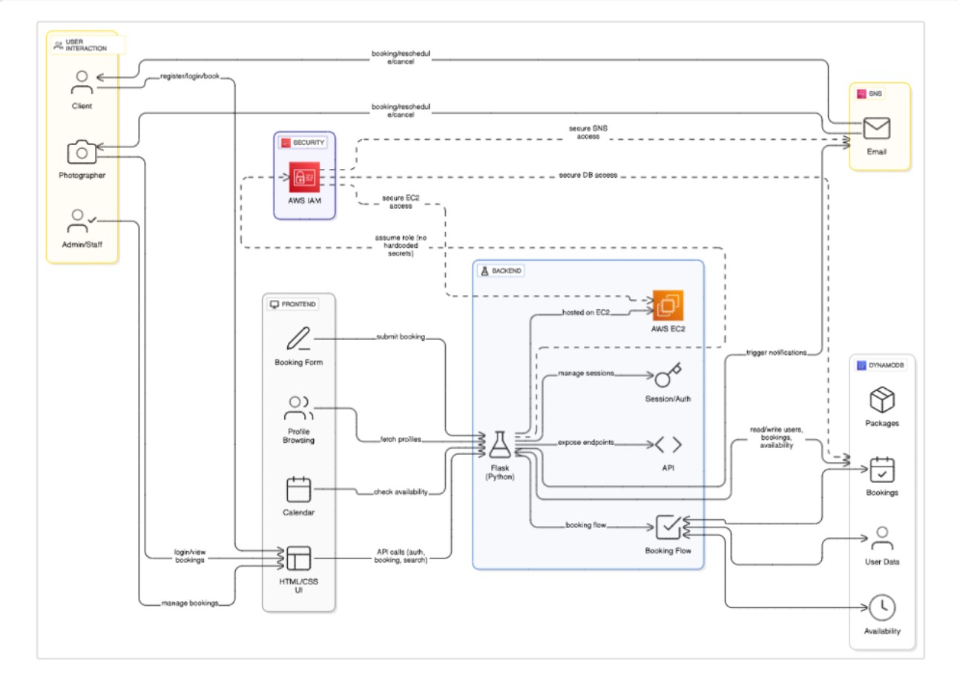

Entity Relationship (ER)Diagram:

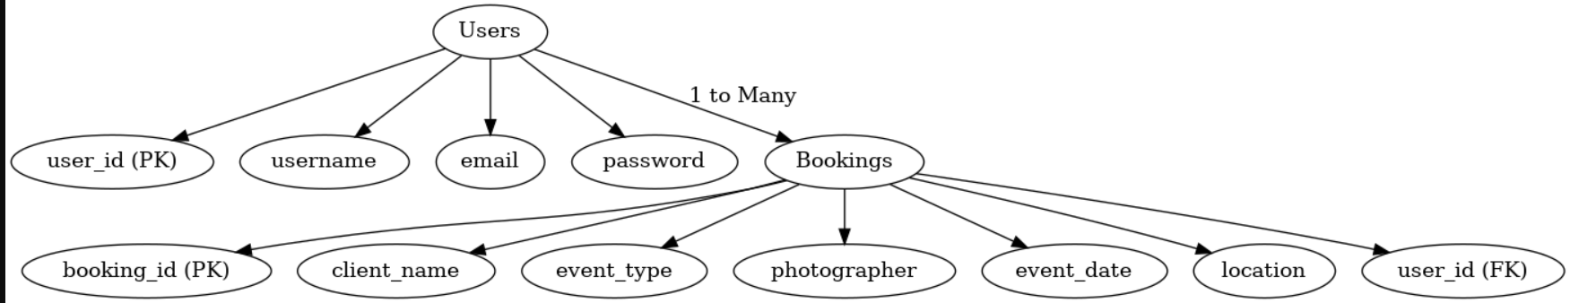

**Pre-requisites:**

1. .**AWS Account Setup**: [AWS Account Setup](https://youtu.be/CjKhQoYeR4Q?si=ui8Bvk_M4FfVM-Dh)
2. **Understanding IAM**: [IAM Overview](https://youtu.be/gsgdAyGhV0o?si=3qg-bULgkD4LXNvR)
3. **Amazon EC2 Basics**: [EC2 Tutorial](https://youtu.be/8TlukLu11Yo?si=MUj0nEAOESRhHUIz)
4. **DynamoDB Basics**: [DynamoDB Introduction](https://docs.aws.amazon.com/dynamodb)
5. **SNS Overview**: [SNS Documentation](https://docs.aws.amazon.com/sns)
6. **Git Version Control**: [Git Documentation](https://git-scm.com/doc)

**Project WorkFlow:**

1. **AWS Account Setup and Login**

**Activity 1.1:** Set up an AWS account if not already done**.**

**Activity 1.2:** Log in to the AWS Management Console

1. **DynamoDB Database Creation and Setup**

**Activity 2.1**: Create a DynamoDB Table.

**Activity 2.2**: Configure Attributes for User Data and Book Requests.

**3.Backend Development and Application Setup**

**Activity 3.1**:Develop the Backend Using Flask.

**Activity 3.2**: Integrate AWS Services Using boto3.

**4.IAM Role Setup**

**Activity 4.1**: Create IAM Role

**Activity 4.2**: Attach Policies

**5.EC2 Instance Setup**

**Activity 5.1**: Launch an EC2 instance to host the Flask application.

**Activity 5.2**: Configure security groups for HTTP, and SSH access.

**6.Deployment on EC2**

**Activity 6.1**:Upload Flask Files

**Activity 6.2**: Run the Flask App

1. **Testing and Deployment**

**Activity 8.1**: Conduct functional testing to verify user registration, login, book requests

# Milestone 1: Web Application Development And Setup

● Activity 1.1: Developed the backend using Flask

* Project Structure

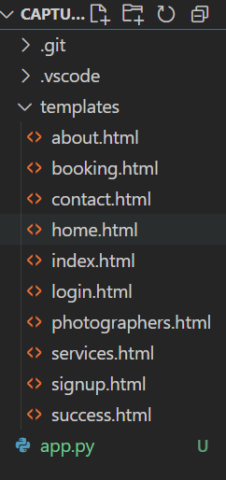

Description : Set up the CaptureMoments project with an [app.py](vscode-file://vscode-app/c:/Users/Sampath/AppData/Local/Programs/Microsoft%20VS%20Code/resources/app/out/vs/code/electron-sandbox/workbench/workbench.html) file, a static/ folder for assets, and a [templates](vscode-file://vscode-app/c:/Users/Sampath/AppData/Local/Programs/Microsoft%20VS%20Code/resources/app/out/vs/code/electron-sandbox/workbench/workbench.html) directory containing all required HTML pages such as home, login, signup, about, photographers, services, contact, booking, and utility pages (e.g., success.html, my_bookings.html). The platform allows users to browse and book professional photographers for various occasions, manage bookings, and explore available photography services, all through a modern, responsive web interface.

**Description of the code :**

* **Flask App Initialization**

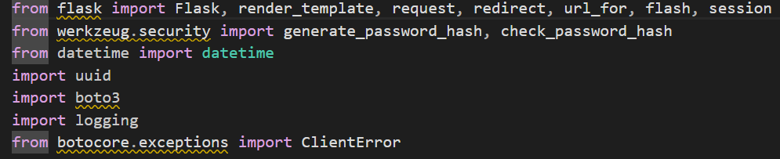

**Description:**  
Import essential libraries including Flask utilities for routing and session management, Boto3 for DynamoDB operations, logging for error tracking, and Werkzeug for password hashing and verification.

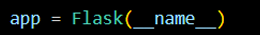

Description: initialize the Flask application instance using Flask(__name__) to start building the web app.

* **DynamoDB setup**

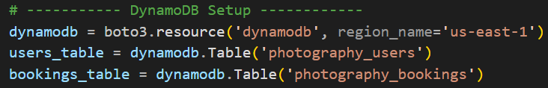

Description: initialize the DynamoDB resource for the us-east-1 region and set up access to the Users and Requests tables for storing user details and book requests.

* **Routes for webpage**
  + **Index route**

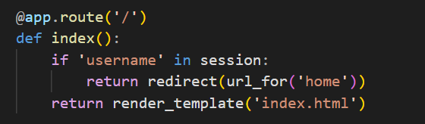

* + **Home route**

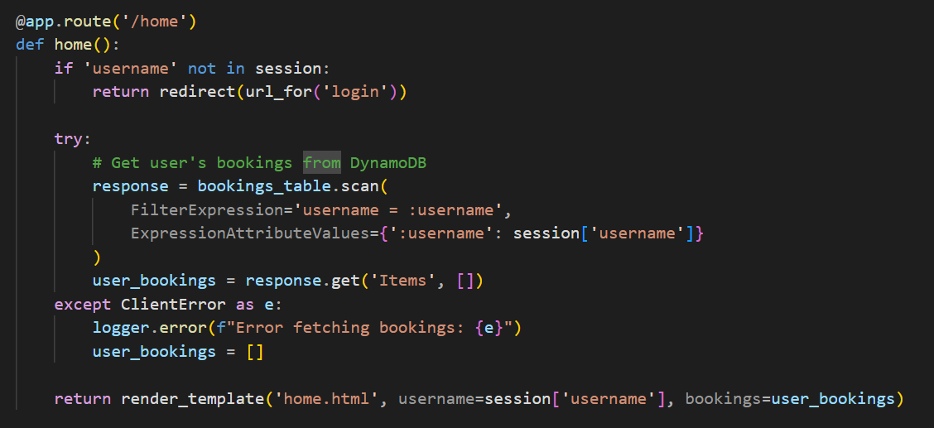

* + **Signup route:**

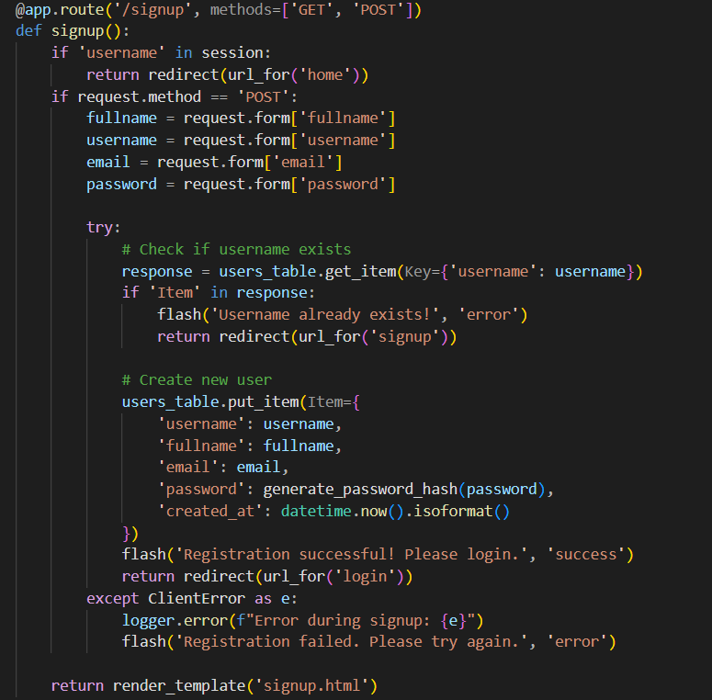

Description:The /signup route handles user registration. If the user is already logged in, it redirects them to the home page. On form submission, it checks if the username already exists in DynamoDB. It creates a new user with the hashed password and saves the data. After successful signup, it flashes a success message and redirects to the login page.

* + **Login route(Get/Post):**

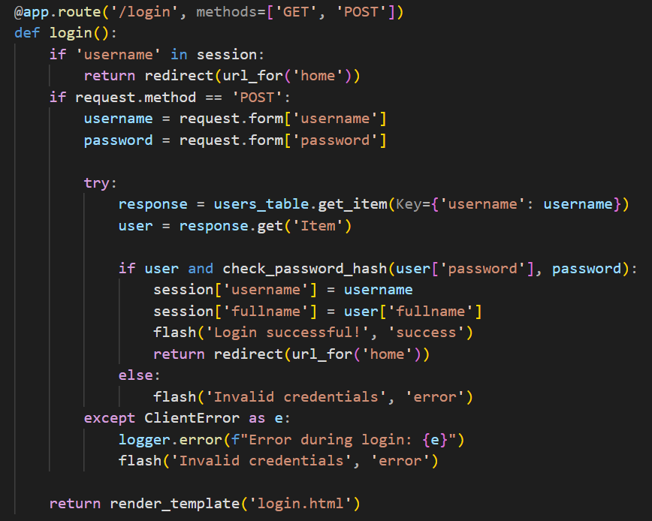

**Description:** define /login route to validate user credentials against DynamoDB, check the Werkzeug for password hashing, update the login count on successful authentication, and redirect users to the home page.

* + **My_Bookings route**

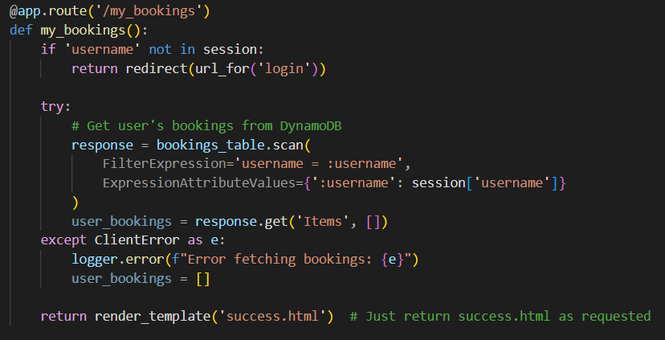

Description:The /my_bookings route fetches and displays bookings of the logged-in user from DynamoDB. If the user isn't logged in, they're redirected to the login page. It then shows the data on success.html.

* + **Booking route**

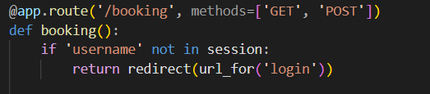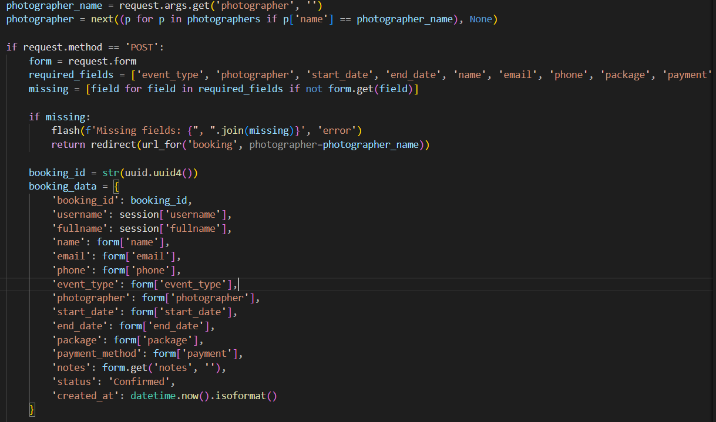

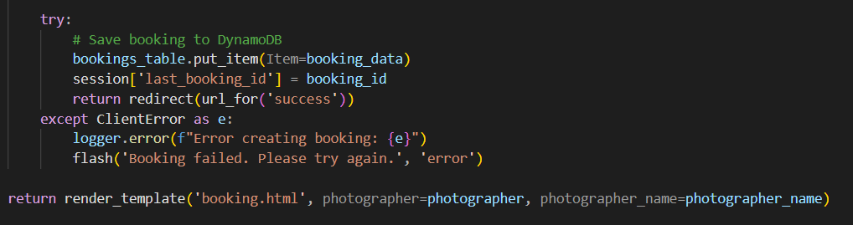

Description :The /booking route lets logged-in users book a photographer. It shows a list of photographers and handles booking form submissions. On POST, it checks for missing fields, generates a booking ID, and saves the booking in DynamoDB. If successful, it redirects to the success page; otherwise, it shows an error.

* + **Success,services,about,photographers routes**

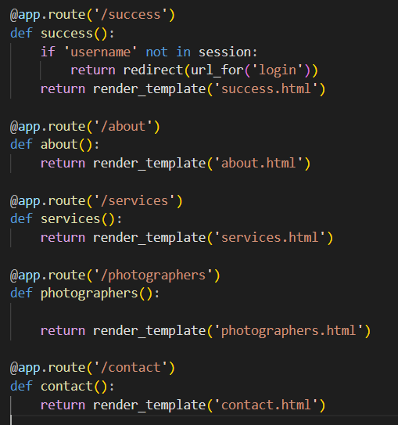

**Description:**These routes handle the main navigation pages of the CaptureMoments platform. The /success route shows a confirmation page after a successful booking, accessible only to logged-in users. The /about route displays information about the platform and its mission. The /services page outlines the types of photography services offered. The /photographers route presents a gallery of available photographers, and the /contact page allows users to reach out with questions or feedback.

* + **Logout route**

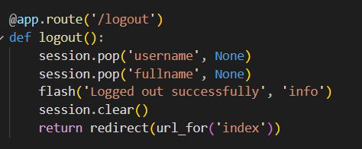

* + **Deployment route**

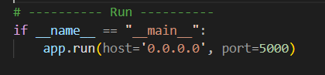

# Milestone 2: AWS Account Setup and Login

* **Activity 2.1: Set up an AWS account if not already done.** 
  1. Sign up for an AWS account and configure billing settings.

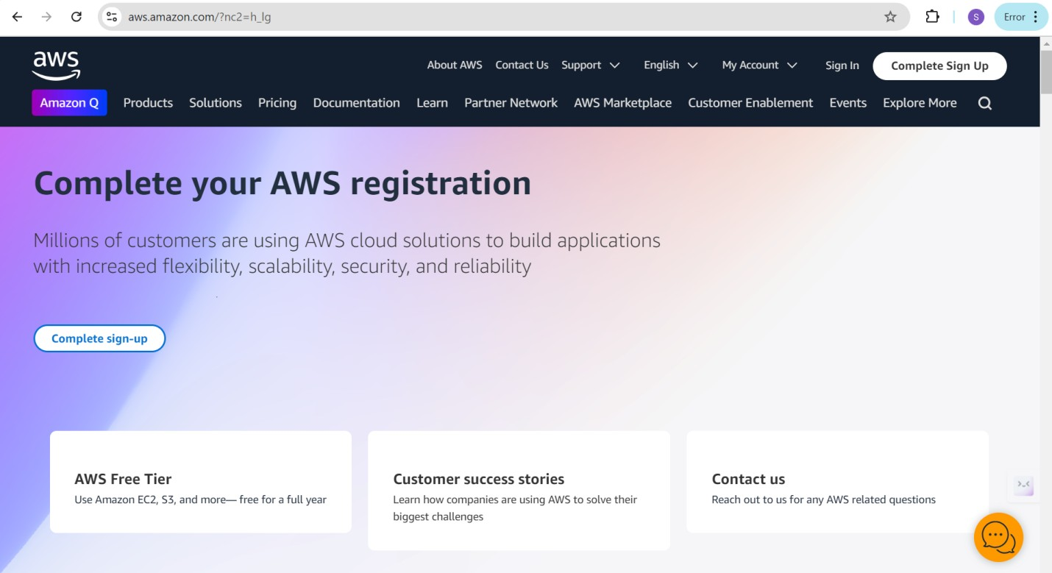

* **Activity 2.2: Log in to the AWS Management Console**

* 1. After setting up your account, log in to the [AWS Management Console](https://aws.amazon.com/console/).

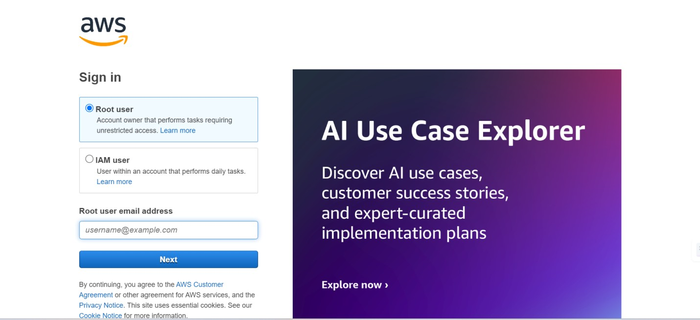

# Milestone 3: DynamoDB Database Creation and Setup

* **Activity 3.1:Navigate to the DynamoDB** 
  1. 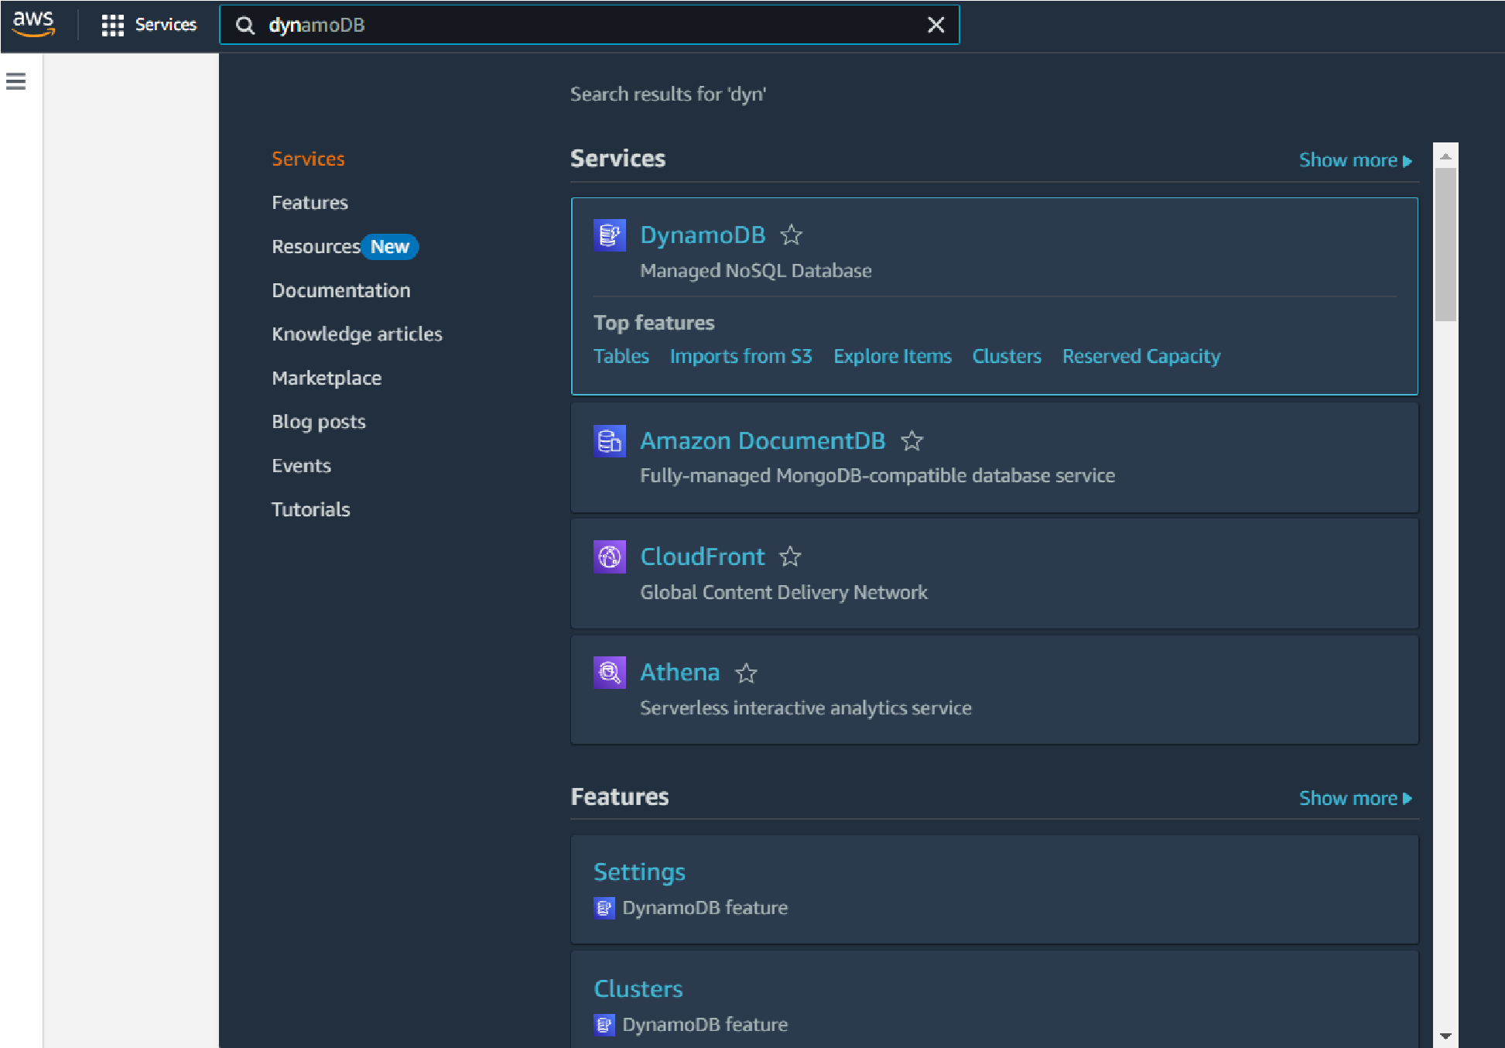In the AWS Console, navigate to DynamoDB and click on create tables.

○

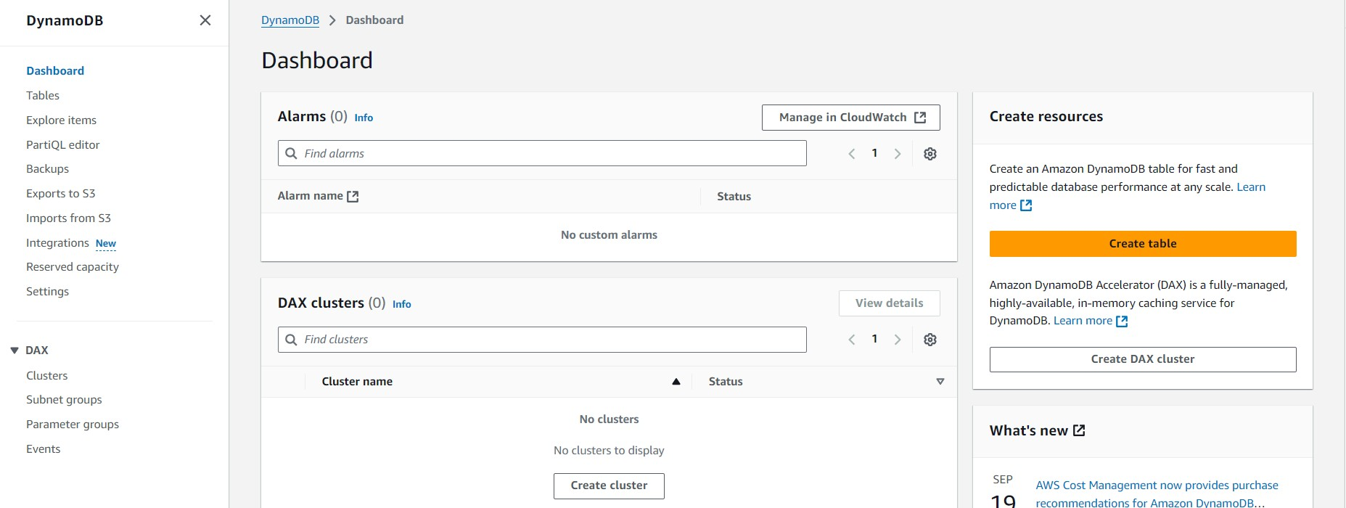

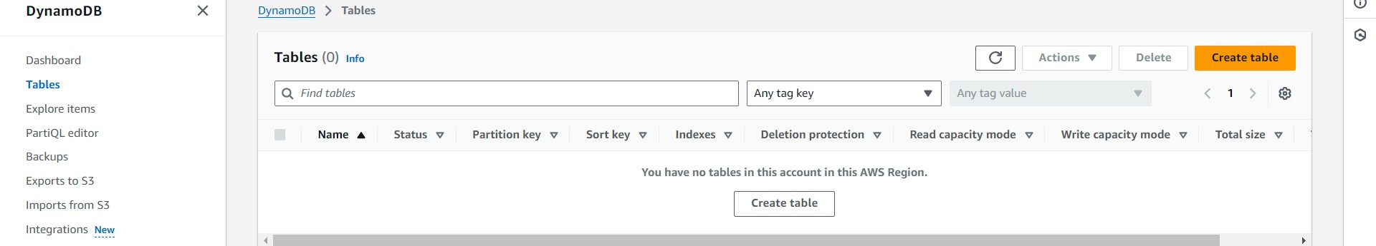

* **Activity 3.2:Create a DynamoDB table for photography_Bookings**
* Create bookings table with partition key “Booking_id”  with type String and click on create tables.

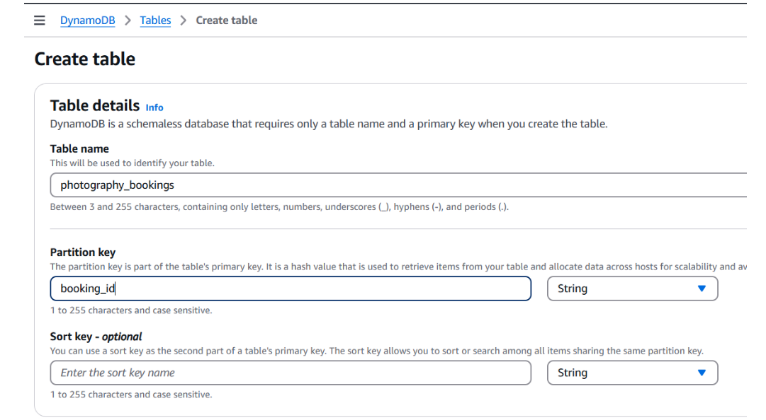

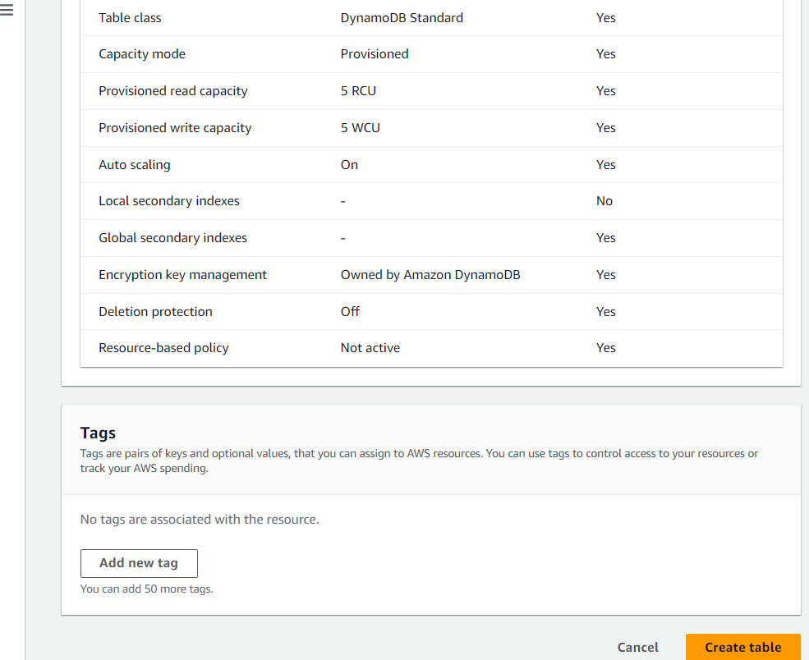

* **Activity 3.3:Create a DynamoDB table for photography_users**

Create Users table with partition key “username”  with type String and click on create tables

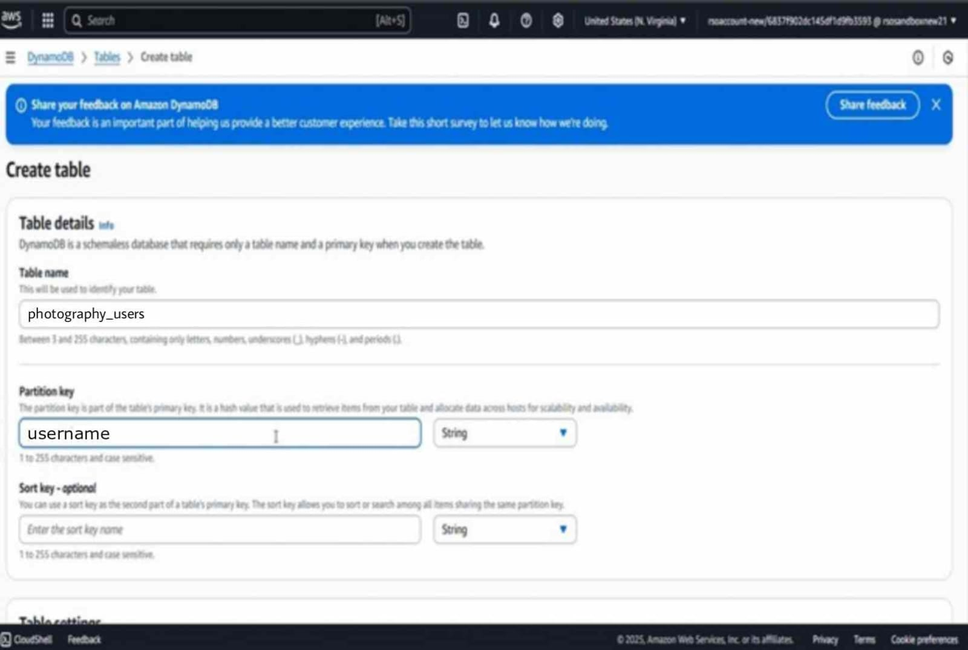

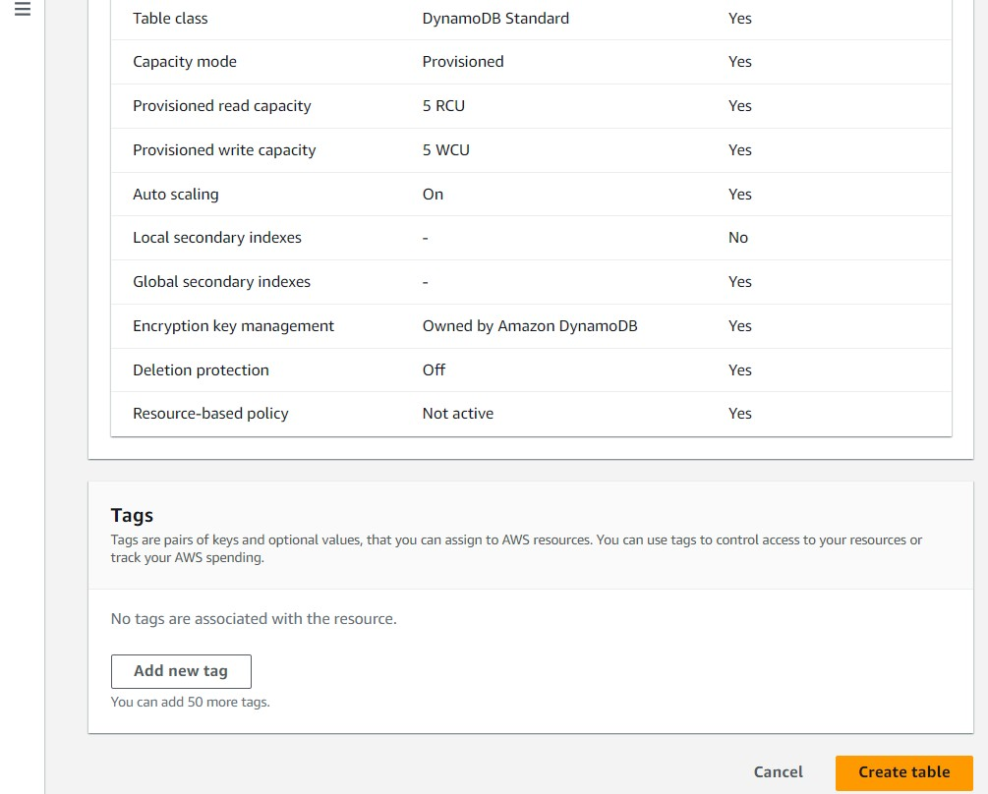

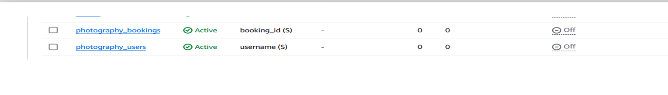

# Milestone 4: IAM Role Setup

* **Activity 5.1:Create IAM Role.**

○ In the AWS Console, go to IAM and create a new IAM Role for EC2 to interact with DynamoDB and SNS.

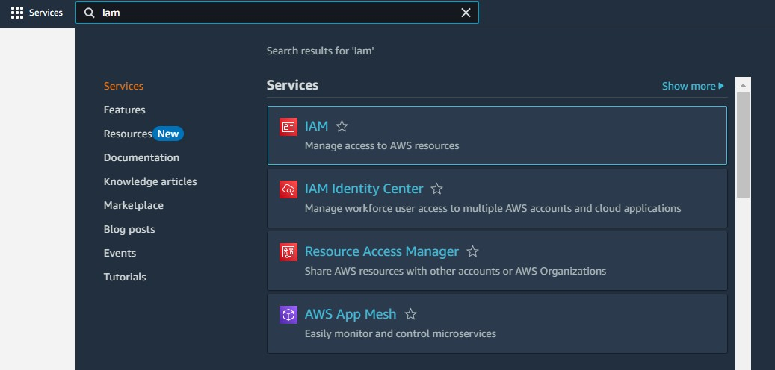

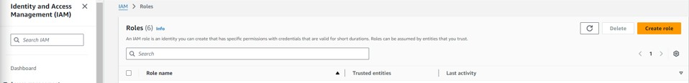

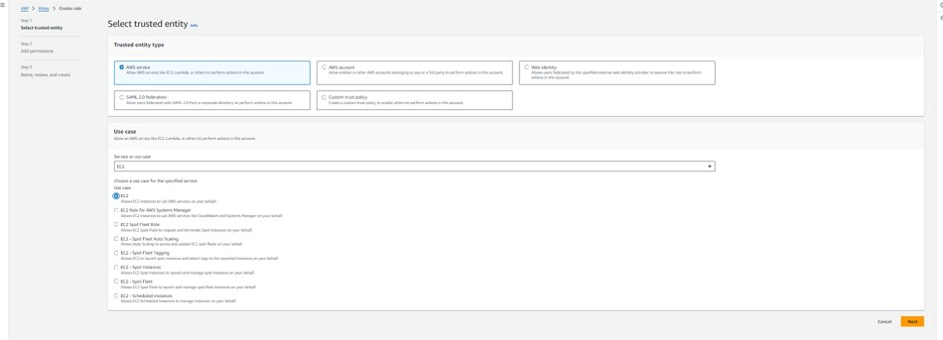

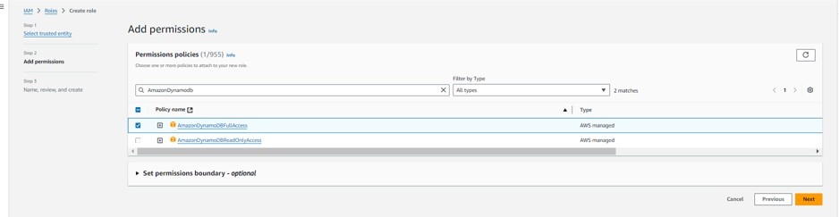

* **Activity 5.2: Attach Policies.**

Attach the following policies to the role:

* AmazonDynamoDBFullAccess: Allows EC2 to perform read/write operations on DynamoDB.

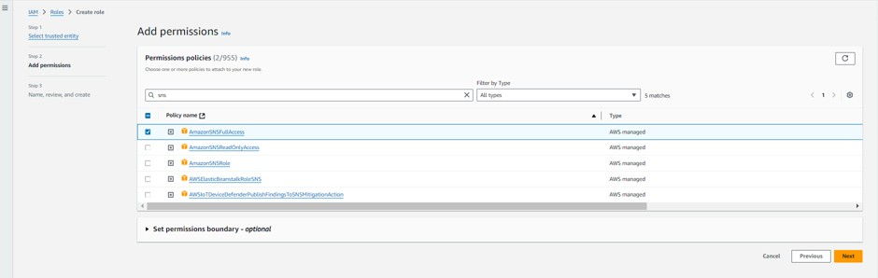

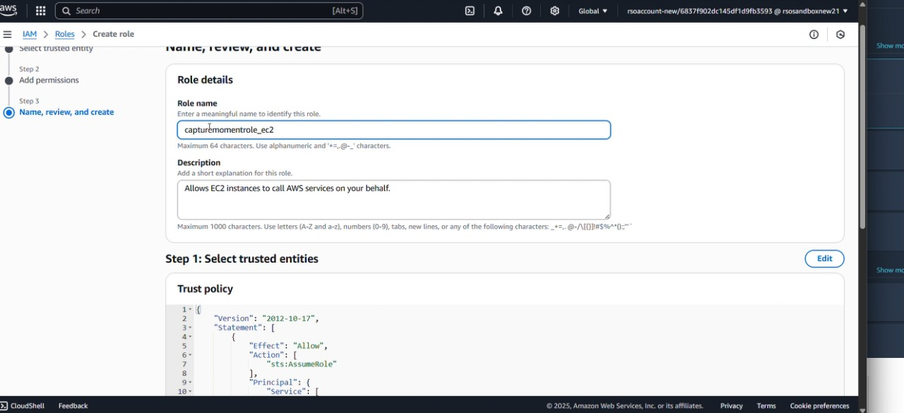

# Milestone 5: EC2 Instance Setup

* **Note: Load your Flask app and Html files into GitHub repository.**

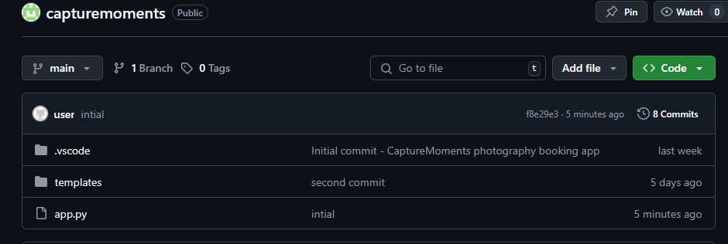

* **Activity 5.1: Launch an EC2 instance to host the Flask application.**

* **Launch EC2 Instance**

○ In the AWS Console, navigate to EC2 and launch a new instance.

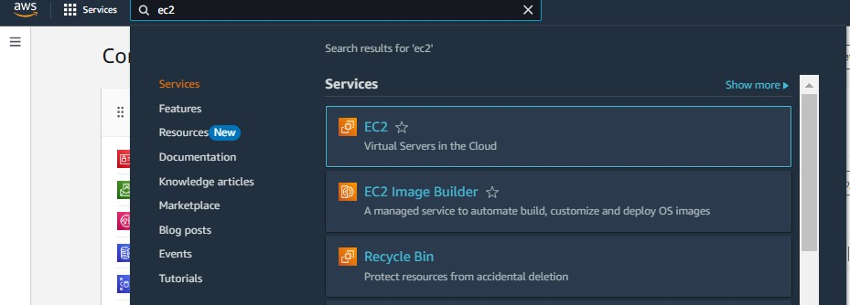

* Click on Launch instance to launch EC2 instance

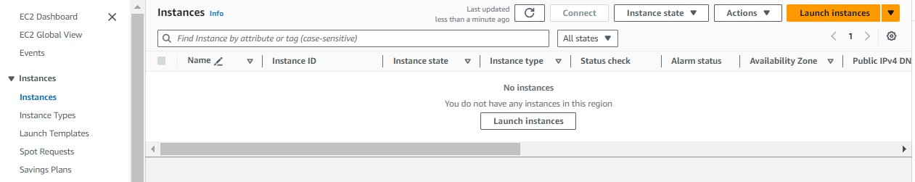

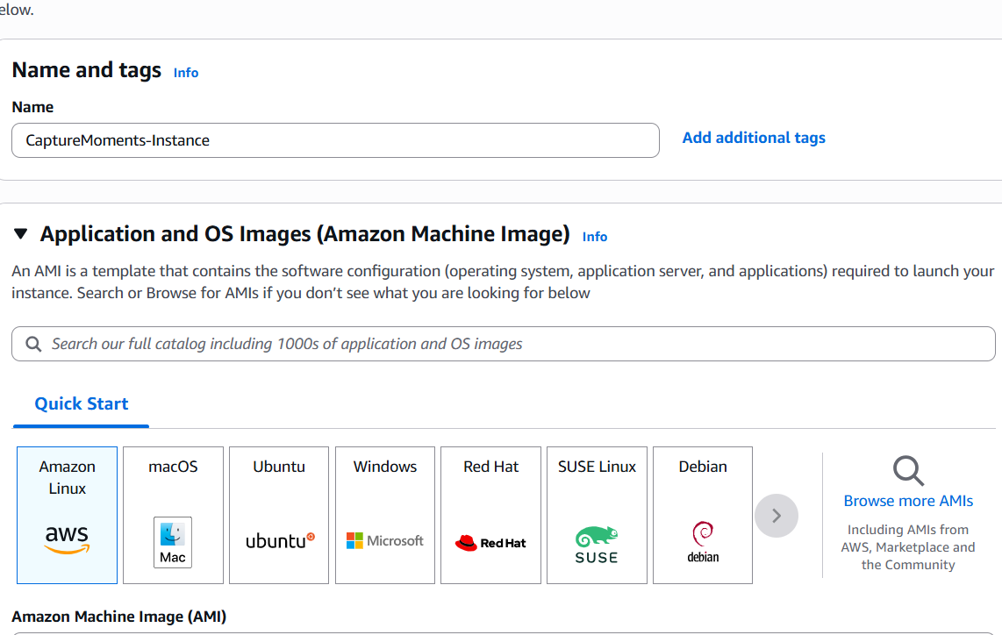

* Choose Amazon Linux 2 or Ubuntu as the AMI and t2.micro as the instance type (free-tier eligible).

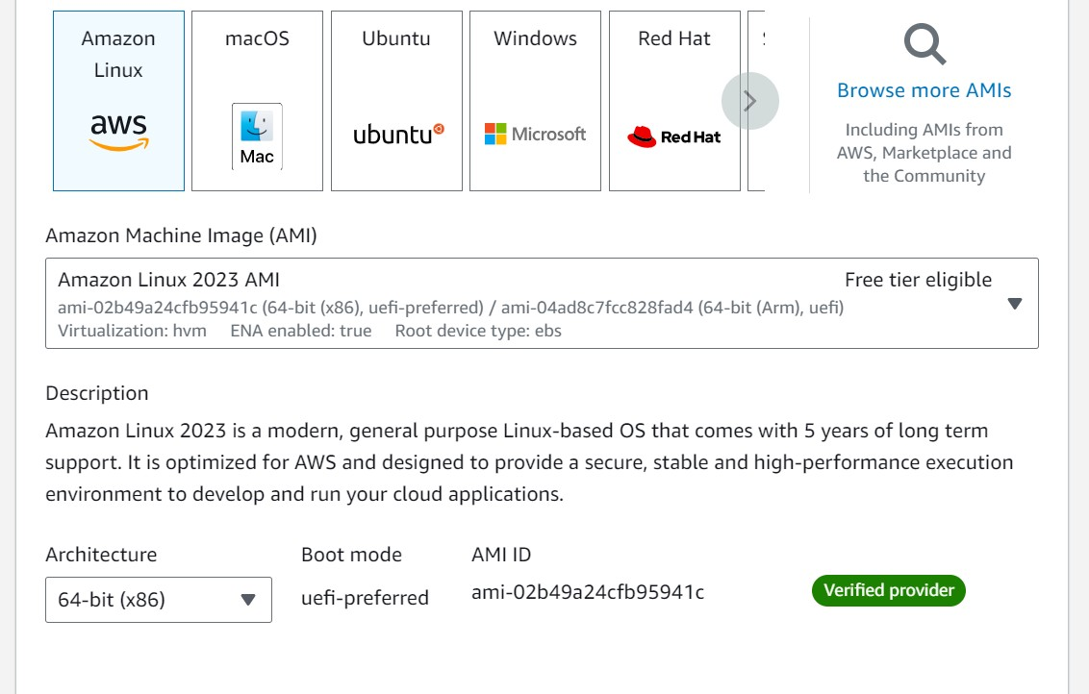

* Create and download the key pair for Server access.

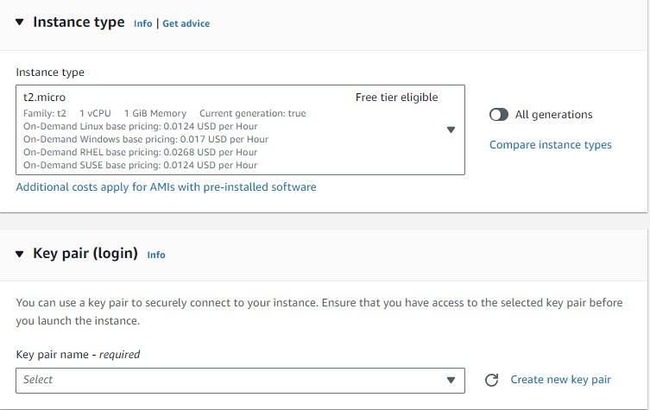

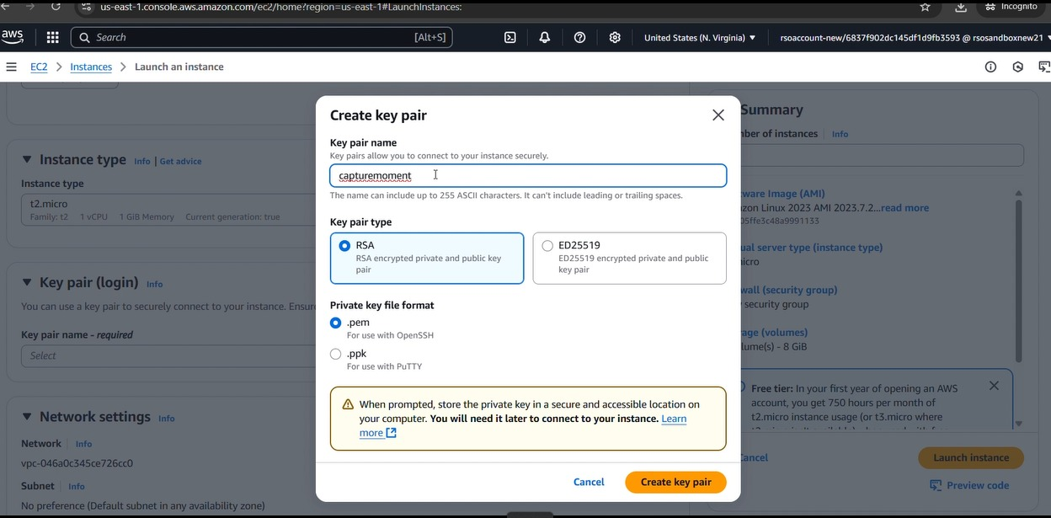

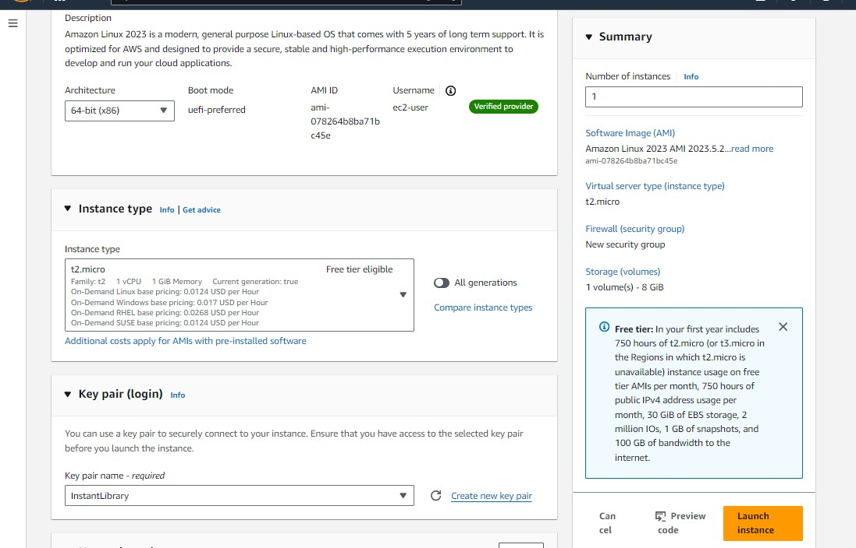

* **Activity 5.2:Configure security groups for HTTP, and SSH access.**

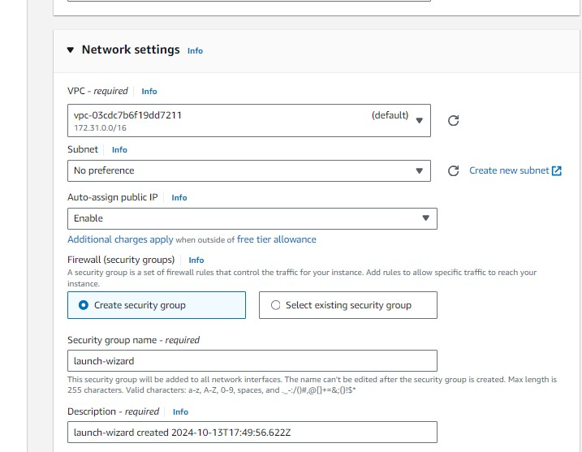

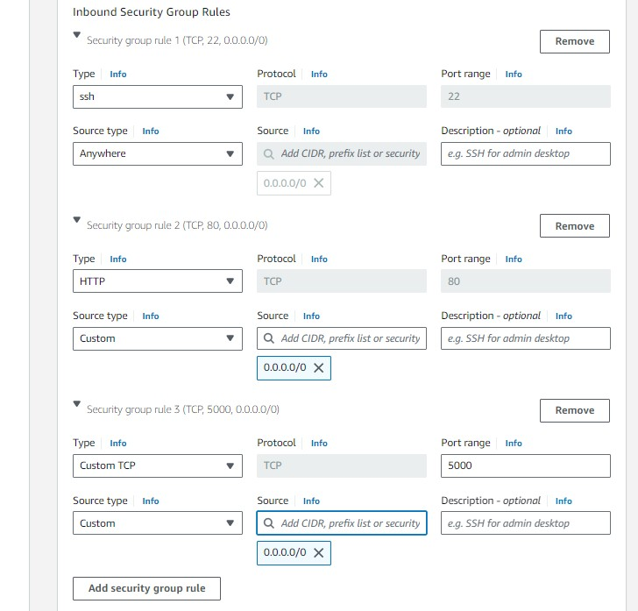

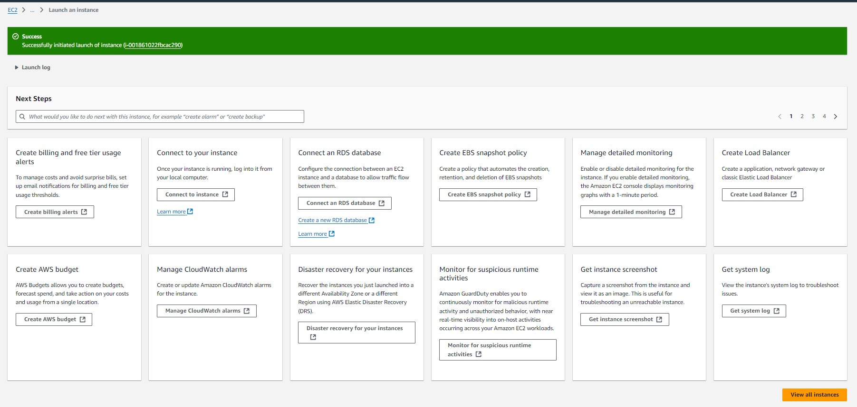

* To connect to EC2 using **EC2 Instance Connect**, start by ensuring that an **IAM role** is attached to your EC2 instance. You can do this by selecting your instance, clicking on **Actions**, then navigating to **Security** and selecting **Modify IAM Role** to attach the appropriate role. After the IAM role is connected, navigate to the **EC2** section in the **AWS Management Console**. Select the **EC2 instance** you wish to connect to. At the top of the

**EC2 Dashboard**, click the **Connect** button. From the connection methods presented, choose **EC2 Instance Connect**. Finally, click **Connect** again, and a new browser-based terminal will open, allowing you to access your EC2 instance directly from your browser.

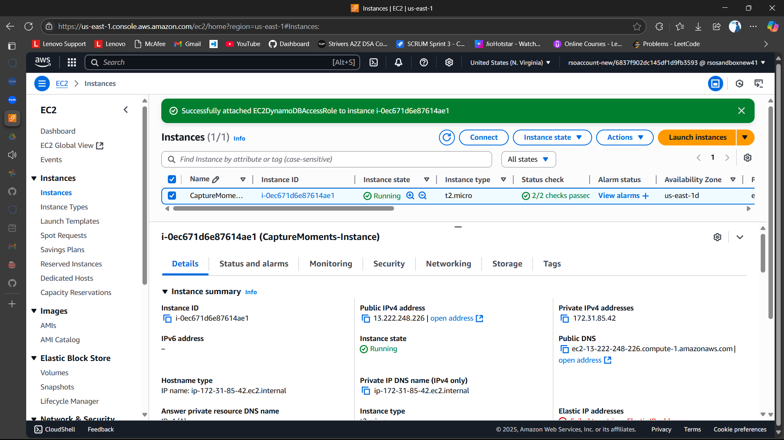

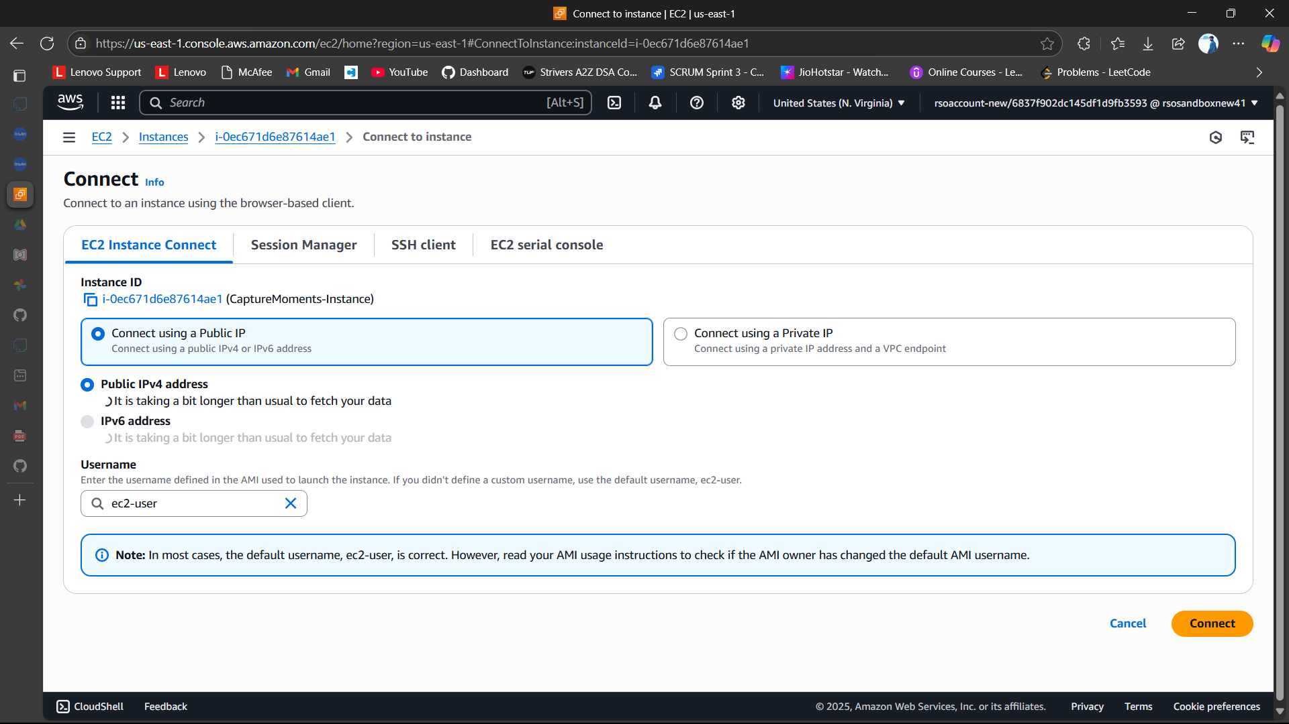

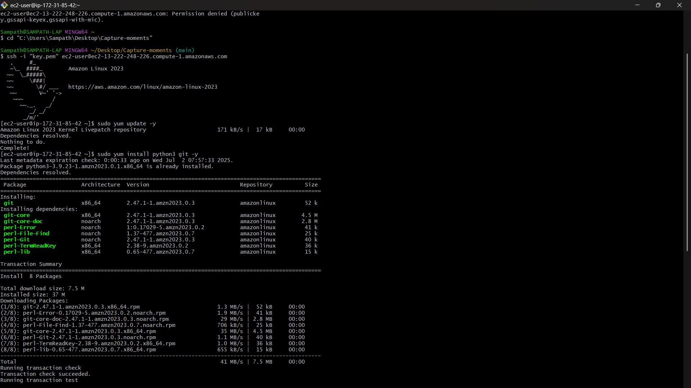

# Milestone 6: Deployment on EC2

**Activity 6.1: Install Software on the EC2 Instance**

Install Python3, Flask, and Git:

On Amazon Linux 2: sudo yum update -y

sudo yum install python3 git sudo pip3 install flask boto3

Verify Installations:

flask --version git --version

**Activity 6.2:Clone Your Flask Project from GitHub**

**Clone your project repository from GitHub into the EC2 instance using Git.**

Run: ‘git clone  [https://github.com/sambgmi/capturemoments.git](%20https://github.com/sambgmi/capturemoments.git)’ Note: change your-github-username and your-repository-name with your credentials here: ‘git clone <https://github.com/sambgmi/capturemoments.git> ● This will download your project to the EC2 instance.

**To navigate to the project directory, run the following command:**

cd capturemometns

**Once inside the project directory, configure and run the Flask application by executing the following command with elevated privileges:**

**Run the Flask Application**

sudo flask run --host=0.0.0.0 --port=80

**Verify the Flask app is running**: http://your-ec2-public-ip

## ○ Run the Flask app on the EC2 instance

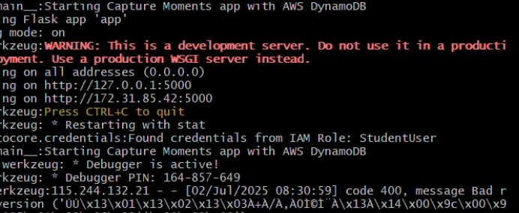

**Access the website through:**

**PublicIPs: https://13.222.248.226:5000**

**Milestone 7: Testing and Deployment**

● **Activity 7.1: Conduct functional testing to verify user registration, login, book requests and photographers**

**Login Page:**

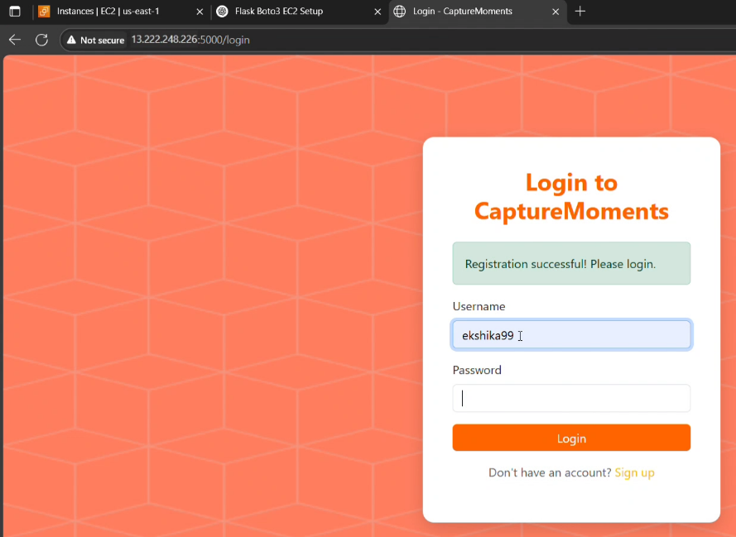

Signup page:

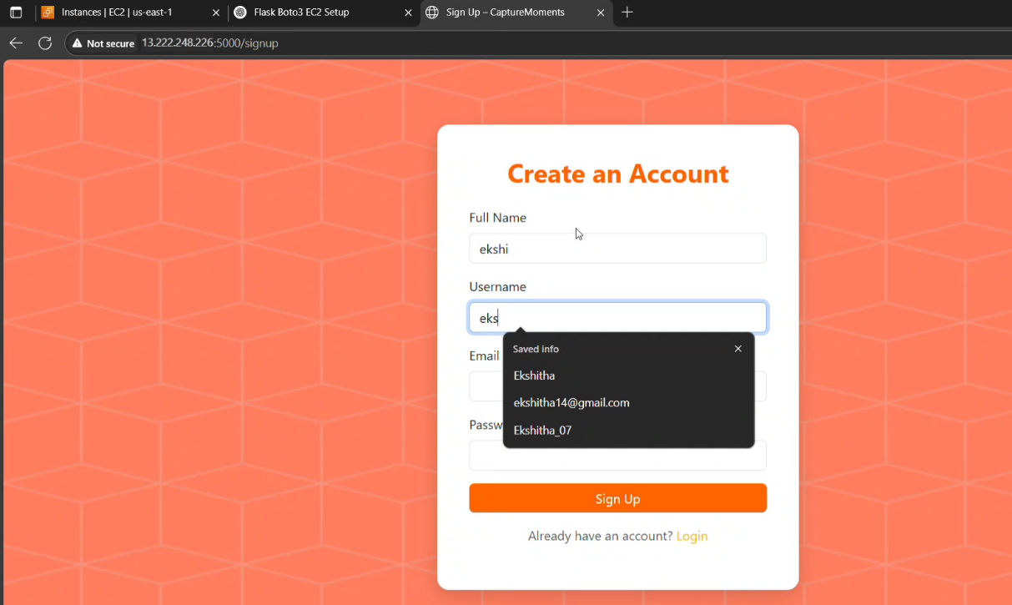

**Photogaprahers Page:**

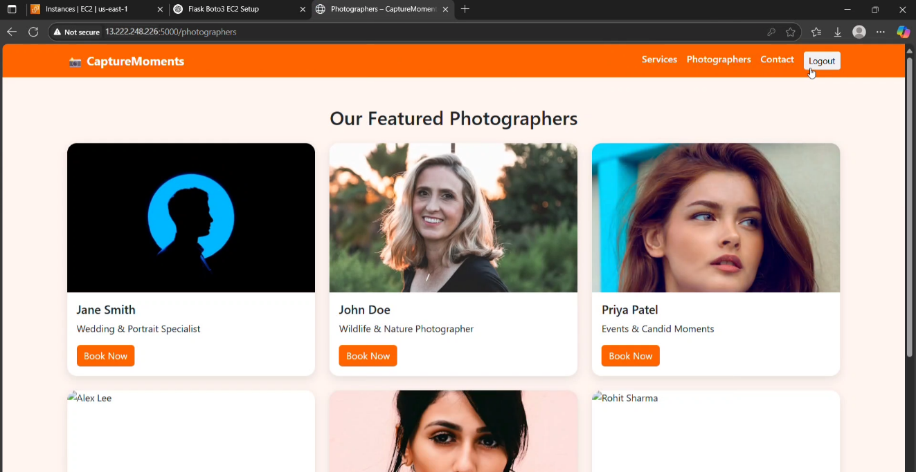

Booking page:

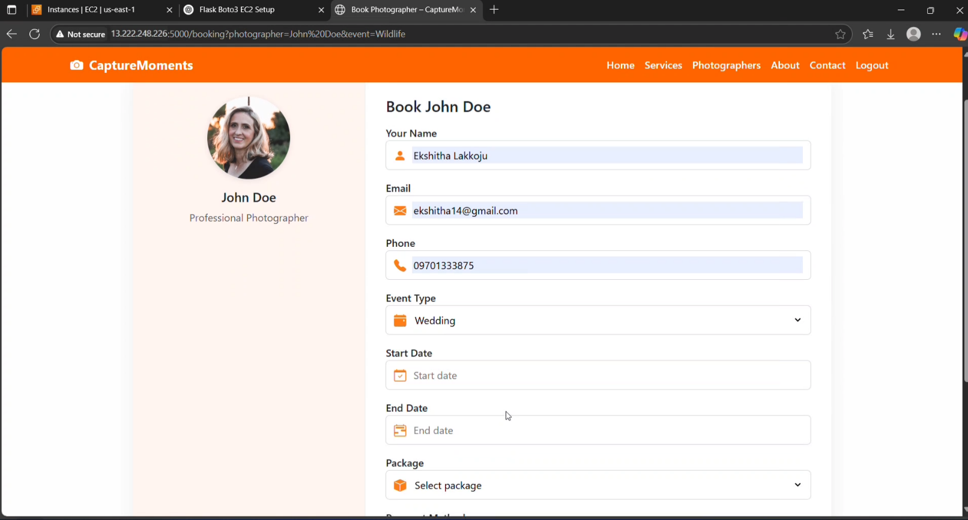

Success page:

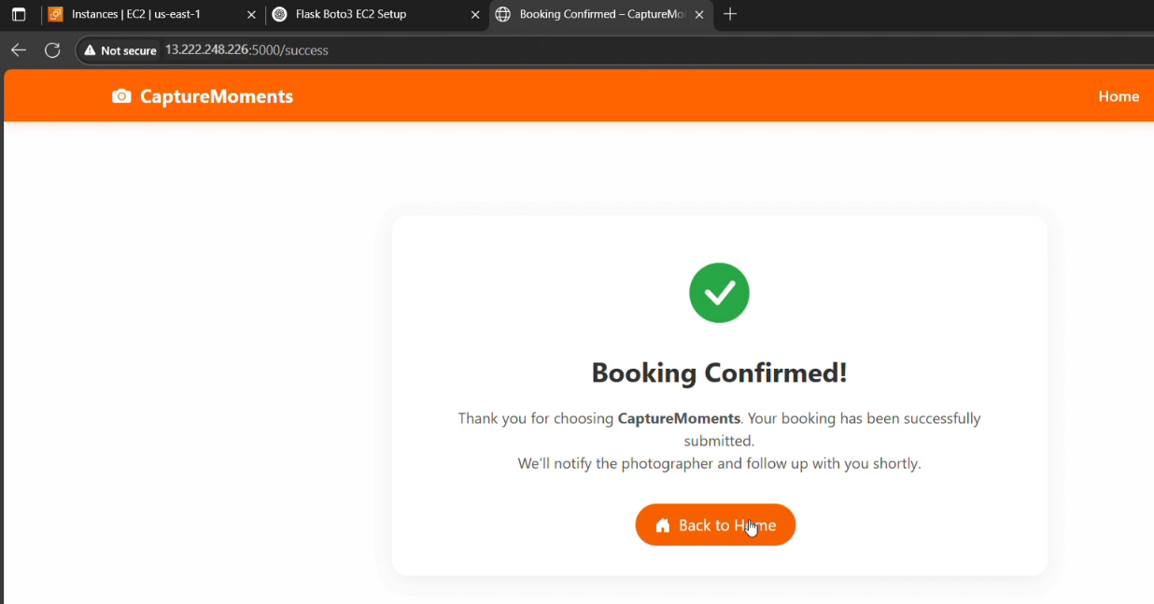

Contact page:

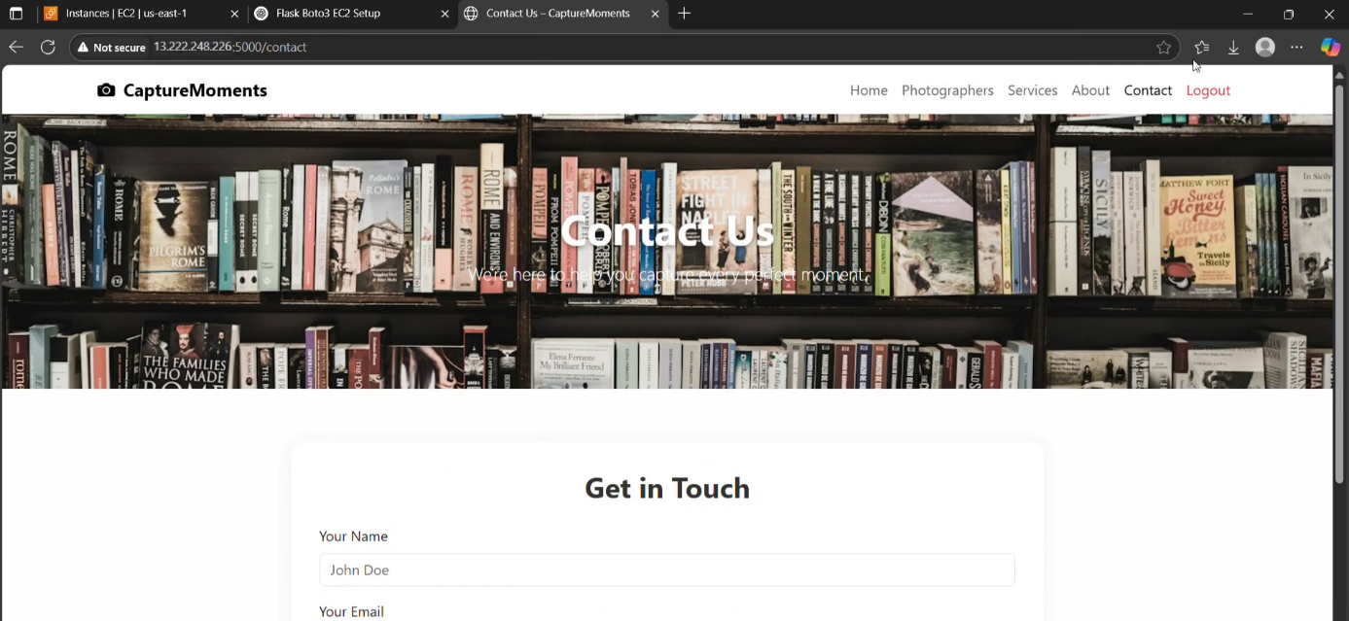

Services page:

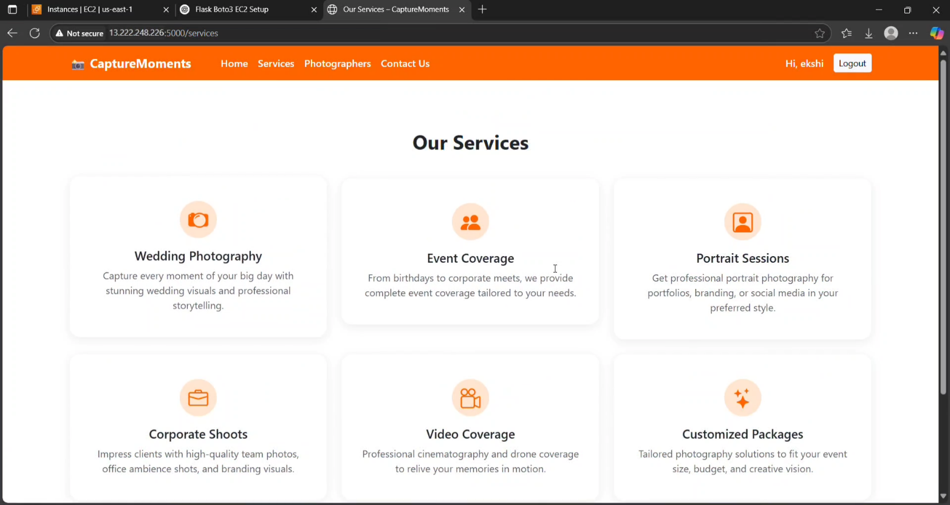

Home page:

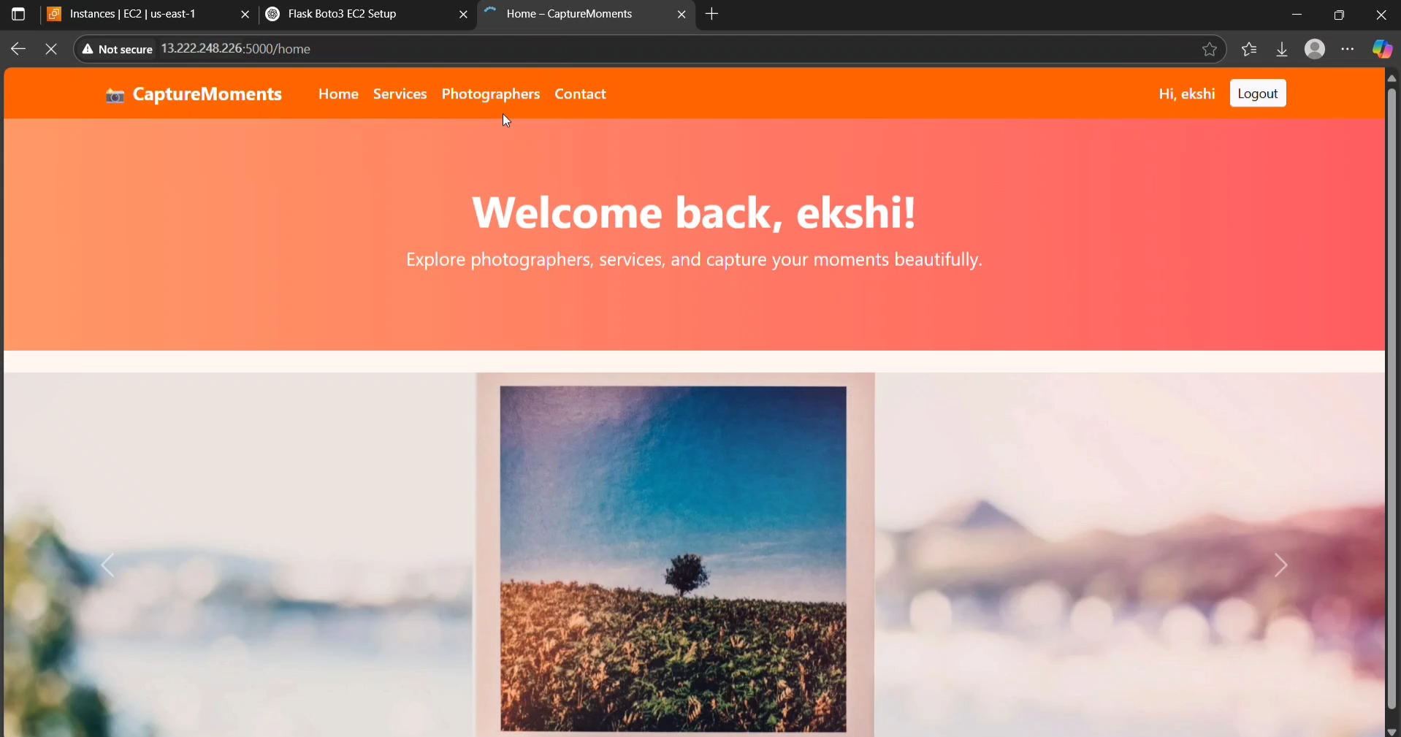

# Conclusion:

The Capture Moments platform has been successfully developed and deployed using a reliable

cloud-based architecture tailored for seamless event photography management. Leveraging

AWS services such as EC2 for hosting and DynamoDB for efficient data storage, the system

ensures high availability, scalability, and quickaccess to media content. Designed to address

the common challenges of disorganized photo sharing and limited storage, the platform in

offers a centralized and user-friendly interface for uploading, organizing, and accessing

event photos. Flask powers the backend operations, enabling smooth workflows for was

user authentication, album creation, and secure photo management. Throughout the in

testing phase, all core functionalities—from user registration to photo uploads and can

album navigation—were validated for performance and reliability. In conclusion, Capture

Moments showcases the potential of cloud-native solutions to transform traditional event

experiences by simplifying the way memories are captured, stored, and shared. This project

stands as a modern, efficient response to the evolving needs of digital photo management in

dynamic event setting